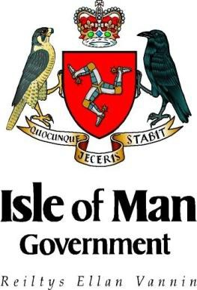
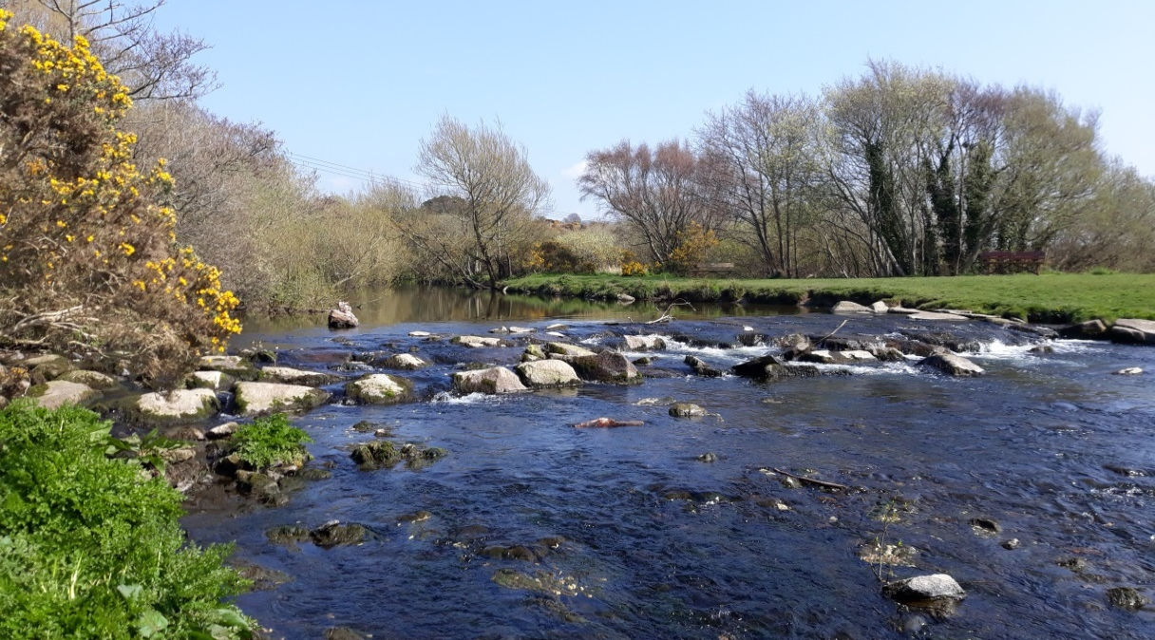
Consultation on the Introduction of Water Quality Objectives and Environmental Quality Standards
Department of Environment, Food and Agriculture
Rheynn Chymmltaght, Bee as Eirinys

Consultation Paper
July 2020
Part 1 - Introduction
- Background

  - History
In March 2018 the Environment and Infrastructure Policy Review Committee made a series of recommendations on future sewerage infrastructure options and how they might impact on bathing water quality in its report “First report 2017-18; Regional Sewage Treatment Strategy, Phase 2”.
In October 2018 DEFA and Manx Utilities (MU) responded to the E&I Policy Review Committee report through an “Interim Scoping Report of what is needed to comply with the EU 2006 Bathing Water Directive”. This report provided an outline of the work required to ensure the Isle of Man achieves compliance with the standards specified in the 2006 Bathing Water Directive.
Within the report, the Strategy for Delivery section included a target of November 2019 to “secure Tynwald approval to adopt bathing water quality standards based on the public health parameters contained in the 2006 Bathing Water Quality Directive and on a strategy for delivering those standards”. The UK consultant APEM was appointed by DEFA in August 2019 to develop this strategy with Phase 1 being approved by Tynwald in December 2019.
The 2018 “Interim Scoping Report of what is needed to comply with the EU 2006 Bathing Water Directive” included a further commitment (Phase 2):-
“By December 2020 secure approval from Tynwald on Manx specific discharge standards and modifications to the licensing provisions in the existing Water Pollution Act which will enable proportionate compliance with the discharge standards. The discharge standards should be based on results from on-going sampling, necessary modelling and a review of the standards adopted in other jurisdictions. Maximum acceptable levels of contaminants from sources other than discharges (i.e. diffuse run off from farms) should be included in the standards”.
APEM has provided expert advice to the Department on the introduction of Environmental Quality Standards for the Isle of Man and the full report can be viewed at; https://www.gov.im/media/1369698/proposed-eqs-apem-report.pdf.
  - Legal Framework
The Water Pollution Act 1993 requires the Department to protect controlled waters (i.e. river, watercourse, lake, pond, well, borehole or coastal waters) from pollution. Section 2(5) of the Water Pollution Act 1993 requires that any scheme proposed for the classification of quality of controlled waters must have Tynwald approval for it to have effect.

  - Benefits of introducing Water Quality Objectives and Environmental Quality Standards
Introducing Water Quality Objectives (WQO) and Environmental Quality Standards (EQS) into the Water Pollution Act is important because it will allow the Department to enforce the legislation as intended to protect the environment. The environmental quality standards have been derived from the EU Water Framework Directive, so the parameters and limits are up to date.
A Water Quality Objective (WQO) means the status set by Government for an area of controlled water to be met by a certain date.
An Environmental Quality Standards (EQS) is defined as the range of concentrations, or just a concentration, of a particular substance in water which should not be exceeded to meet the WQO. For example the WQO recommended for Bathing Waters is Good Status in accordance with the EU 2006 Bathing Water Directive which requires corresponding EQS of Intestinal Enterococci < 200 CFU/100ml and Esherichia Coli < 500 CFU/100ml, see Table 4.
The environmental quality standards will lead to updating water quality objectives for the Island’s watercourses. The current water quality objectives were set by DEFA in 2001.
- Objectives

- To seek views from the public on the proposed environmental quality standards as detailed in Tables 1-3.
- To seek views from the public on the recommendation as outlined by the external consultants APEM on introducing the environmental quality standards

Part 2 - The Consultation
The Department of Environment, Food and Agriculture is seeking views on proposals to introduce Water Quality Objectives (WQO) and Environmental Quality Standards (EQS) to assess water quality and monitor compliance for inland, coastal and bathing waters in the Isle of Man.

The Department welcomes your responses to the following questions along with any additional comments on the proposals that you consider may be of relevance. This consultation will run for a period of 3 months.
Section 1 - Introduction
Question 1
Tell us about yourself.
Name:
To ensure that the process is open and honest responses can only be accepted if you provide your full name with your response. If we publish a summary of responses your name will not be published.

Section 2 - Environmental Quality Standards (EQS) – Tables 1-3
Question 2
It is important to protect Manx rivers, streams, lakes and reservoirs from pollutants such as from agricultural run-off, sewage discharges, heavy metal contamination and pesticides. Please provide your views on the table below which sets out the proposed EQS for inland waters.
More information can be found in Section 4 of the APEM report on the proposed EQS for the Isle of Man; https://www.gov.im/media/1369698/proposed-eqs-apem-report.pdf
Table 1. Summary of the EQS for inland waters
Parameter | Mean value | Maximum or percentile concentration | Type of parameter
Ammonia (total as N 90%ile, mg/l) | - | 0.3 | Physico-chemical parameter
Biochemical oxygen demand (BOD 90%ile, mg/l) | - | 4 | Physico-chemical parameter
Dissolved oxygen (as percentage saturation, 10%ile)) | - | 75 | Physico-chemical parameter
pH (5 and 95 percentiles) | - | >6 to <9 | Physico-chemical parameter
Nitrate (as NO3, mg/l) | - | >5 to 10 | Nutrient
Phosphorus (as P, mg/l) | 0.046 | - | Nutrient
Arsenic (µg/l) | 50 | - | Heavy metal
Cadmium (µg/l) | EQS will be site specific | - | Heavy metal
Copper (µg/l) | EQS will be site specific | - | Heavy metal
Iron (µg/l) | 1000 | - | Heavy metal
Nickel (µg/l) | EQS will be site specific | - | Heavy metal
Lead (µg/l) | 1.2 | - | Heavy metal
Manganese (µg/l) | EQS will be site specific | - | Heavy metal
Mercury (µg/l) | - | 0.07 | Heavy metal
Zinc (µg/l) | EQS will be site specific | - | Heavy metal
Benzo(a)pyrene (used as an indicator for poly aromatic hydrocarbons) | 0.00017 | 0.27 | Chemical
PCBs |  | 15 ng/l | Chemical
Pesticides | The EQS will be specific for the type of pesticide |  | Chemical
Solvents | The EQS will be specific for the type of solvent |  | Chemical
Surfactants | The EQS will be specific for the type of surfactant |  | Chemical

Question 3
Manx coastal waters receive a range of potentially polluting substances which are discharged from inland waters; including heavy metals and chemicals which could impact shellfish populations and ultimately human health. Please provide your views on the proposed EQS for coastal waters detailed in Table 2.
More information can be found in Section 4.10 in the APEM report on proposed EQS for the Isle of Man; https://www.gov.im/media/1369698/proposed-eqs-apem-report.pdf
Table 2. EQS for coastal water (in µg/l unless otherwise stated)
Parameter | Mean value | Maximum concentration* | Sediment (µg/kg) | Biota (µg/kg) | Reason for including
Arsenic | 25 | - |  |  | May bioaccumulate in shellfish and fish
Benzo(a)pyrene (used as an indicator for poly aromatic hydrocarbons) | 0.00017 | 0.027 |  |  | May bioaccumulate in shellfish and fish
Cadmium | 0.2 | - |  |  | May bioaccumulate in shellfish and fish
Chlorine | - | 10 |  |  | To control risk from overuse used for controlling algae in marinas
Chromium | 0.6 | 32 |  |  | May bioaccumulate in shellfish and fish
Copper | 3.76 | - |  |  | May bioaccumulate in shellfish and fish
Dissolved inorganic nitrogen (micromoles per litre) | - | 18.7 |  |  | For control of algal blooms
Dissolved inorganic phosphorus (micromoles per litre) |  | 0.74 |  |  | For control of algal blooms
Dissolved oxygen (mg/l) | - | 4* |  |  | Will cause stress/death of fish and other animals
Iron | 1000 | - |  |  | Toxic to aquatic organisms
Lead | 1.3 | 14 |  |  | May bioaccumulate in shellfish and fish
Mercury | - | 0.07 |  |  | May bioaccumulate in shellfish and fish
Nickel | 8.6 | 34 |  |  | May bioaccumulate in shellfish and fish
Polychlorinated biphenyls - congeners |  |  |  |  | May bioaccumulate in shellfish and fish
- PCB28 |  |  | 1.7 | 64
- PCB52 |  |  | 2.7 | 108
- PCB101 |  |  | 3.0 | 120
- PCB118 |  |  | 0.6 | 24
- PCB138 |  |  | 7.9 | 316
- PCB153 |  |  | 40 | 1600
- PCB180 |  |  | 12 | 480
PCBs | - | 15 ng/l | - | - | For discharges into water, no individual PCB (from the list of PCBs in the table) should exceed 15 ng/l.
pH | - | >6 and <9* |  |  | For control of algal blooms
Tributyltin | 0.0002 | 0.0015 |  |  | May cause toxicological effects in shellfish
Unionised ammonia | 21 | - |  |  | May cause toxicological effects in fish
Zinc | 6.8 | - |  |  | May bioaccumulate in shellfish and fish

Question 4
Bathing water quality is important for the protection of the public health and tourism. Each designated bathing water in the Isle of Man will have information available on the catchment in terms of sewerage infrastructure, potential sources of pollution and previous monitoring results. All of this information will allow the public to decide when and where to bathe and a target of ‘Good’ status has been agreed by Tynwald as the minimum standard.
The standards outlined in Table 3 are the same as the EU 2006 Bathing Water Directive which has been adopted by the UK and across Europe. By bringing the Isle of Man standards in line with other jurisdictions it will benefit tourists and locals as more information will be available for each location and the signage will be similar to other countries.
Please provide your views on the Bathing Water EQS detailed in Table 3.
More information can be found in Section 4.2 of the APEM report on proposed EQS for the Isle of Man; https://www.gov.im/media/1369698/proposed-eqs-apem-report.pdf
Table 3. EQS for Bathing Waters (in CFU/ 100 ml)
Parameter | Excellent status | Good status | Sufficient status
Intestinal enterococci | 100 | 200 | 185
Escherichia coli | 250 | 500 | 500

Section 3 – Summary of external consultant (APEM) recommendations
The external consultancy APEM was contracted in 2019 to assist DEFA with introducing Environmental Quality Standards (EQS) into Manx legislation to increase environmental protection. All of the proposed EQS provided in the APEM report are in line with the current UK regulations and any amendments to the standards will be reviewed by DEFA as necessary.
Within the report APEM provide a series of recommendations and DEFA would like your views on these. A summary of the recommendations is included in Section 10 of the report, https://www.gov.im/media/1369698/proposed-eqs-apem-report.pdf.
Question 5
As part of introducing WQO and EQS a review will be undertaken of the water quality objectives for all monitored sites which were initially set in 2001. In line with this review APEM has recommended that ‘Good’ status is set as a minimum standard for all controlled waters. This is in line with the agreement by Tynwald in December 2019 to achieve ‘Good’ bathing water quality.
Please provide your views on the approach outlined above.

Question 6
APEM has recommended that a risk based approach is used to identify the substances which require monitoring in each river.
This approach will enable the Isle of Man to monitor for a smaller suite of chemicals as a large proportion which are included in UK regulations will not be present on the island. More monitoring and discussions with the industry will be required to assess which chemicals are used and where they may enter a waterbody. After this assessment has been completed a decision will be made on whether an EQS is required for the specific parameter.
In Section 5 of the APEM report a review has been completed into the environmental protection measures in other jurisdictions such as the UK, Guernsey and Jersey. This review has enabled APEM to tailor its approach to the known issues and resources available on the Isle of Man. More information can be read at; https://www.gov.im/media/1369698/proposed-eqs-apem-report.pdf
Please provide your views on the risk based approach to be used on the Isle of Man.

Question 7
APEM has recommended to update the nutrient and chemical environmental quality standards in line with UK standards. More information is included in Sections 4.4 and 4.6 of the report, https://www.gov.im/media/1369698/proposed-eqs-apem-report.pdf
Chemical environmental quality standards will be developed if they are in widespread use or pose a potential risk to the water quality. This assessment will be made using current records and then target monitoring in known locations to assess concentrations to determine its impact on water quality.
Agricultural pollution can enter the marine environment by run off from agricultural land or by entering drainage ditches which lead to a nearby watercourse. The main pollutants are;
- Nutrients (phosphates and nitrates)
- Chemicals including pesticides and veterinary medicines
- Faecal bacteria and pathogens
- Soil sediment
- Micro plastics
The pressures and impacts on water quality from the above pollutants includes;
- Eutrophication
- Loss of biodiversity
- Silting of fish spawning grounds
- Risks to human health via bathing and water contact sports
- Damage to fisheries, tourism and recreation
- Damage to shell fisheries’
Please provide your views on updating the nutrient and chemical environmental quality standards for the Isle of Man.

Question 8
Across the Isle of Man there are multiple abandoned mine sites which continue to pollute our watercourses. Pollution from coal mines is easy to see, because of the iron rich water they discharge can cause rivers to turn orange. Not all pollution is obvious from abandoned mines, it may not be visible, and we can only tell if metals are present in rivers by assessing the water quality.
Therefore APEM recommended to introduce heavy metal environmental quality standards and to update the monitoring programme to include heavy metals for specific sites depending on background monitoring and the presence of a specific metal.
Pollution from abandoned mines comes from;
- ‘Point sources’ where drainage tunnels or mine entries discharge metal rich mine waters all year round.
- ‘Diffuse sources’ such as mine wastes, metal-contaminated sediments and groundwater contribute to increasing amounts of metals as river flows increase due to adverse weather.
- Impacts on groundwater and aquifers.
Please provide your views on introducing heavy metal environmental quality standards to reduce the input into watercourses. More information can be found in Section 4.5 of the APEM report; https://www.gov.im/media/1369698/proposed-eqs-apem-report.pdf

Question 9
Please provide any additional comments; more information and a summary of the recommendations are outlined in Section 10 of the APEM report, https://www.gov.im/media/1369698/proposed-eqs-apem-report.pdf

- Feedback to the consultation
  - Responses
Responses should be sent in writing and preferably by email to:-
Environmental Quality Standards Consultation
Environmental Protection Unit
Environment Directorate
Department of Environment, Food and Agriculture
Foxdale Road
St Johns
Isle of Man
IM4 3AS

Should you require a paper copy of the consultation document please contact the Environmental Protection Unit at environmentalprotection@gov.im or on 01624 685885.

Copies of this document may be downloaded from the Isle of Man Government website at https://consult.gov.im

It is important to note these proposals have been prepared for the purposes of consultation and that further refinement may take place in the light of responses received.

The closing date for the receipt of comments is 17:00 on Wednesday 7th October 2020.

Unless specifically requested otherwise (see below), responses received may be published either in part or in their entirety. If you are responding on behalf of a group, it would be helpful to make your position clear. To ensure that the process is open and honest responses can only be accepted if you provide your full name with your response.

It may be useful when giving your feedback to make reference to the specific proposal(s) set out in the document that you wish to comment on/discuss.

The purpose of consultation is not to be a referendum. It is an information, views and evidence gathering exercise from which to take an informed decision on the content of proposed legislation or policy. As with any consultation exercise, the responses received do not guarantee changes will be made to what has been proposed.

  - Other information

If you have any views or observations or there is some point of clarification you would like to receive in relation to the topics in this document or any other issue related to the subject of the consultation you are invited to submit these in writing to:

Environmental Protection Unit
Department of Environment, Food & Agriculture
Thie Slieau Whallian
Foxdale Road
St John’s
IM4 3AS

Email: environmentalprotection@gov.im

  - Confidentiality

In line with DEFA’s policy of openness, at the end of the consultation period copies of the responses we receive may be published in a summary of the responses to this consultation. If you do not consent to this, you must clearly request that your response be treated as confidential. The summary would not contain any personal information that would identify you. Any confidentiality disclaimer generated by your IT system in email responses will not be treated as such a request. Respondents should also be aware that there may be circumstances in which DEFA will be required to communicate information to third parties on request, in order to comply with its obligations under the Freedom of Information Act 2015.

  - Handling Results

A summary of responses will be posted on the Department’s website within 3 months of the close of the consultation period and will also be available from the Tynwald library and the Department’s head office. Information received will be dealt with in accordance with the access to information regimes. These are primarily the Public Engagement and Consultation Principles and the Code of Practice on Access to Information.

This consultation follows the Isle of Man Government Public Engagement and Consultation Principles (October 2017). If you have any comments on how this consultation has been carried out, please contact Mr Richard Lole, Chief Executive of DEFA, at the Department’s head offices in St Johns.

