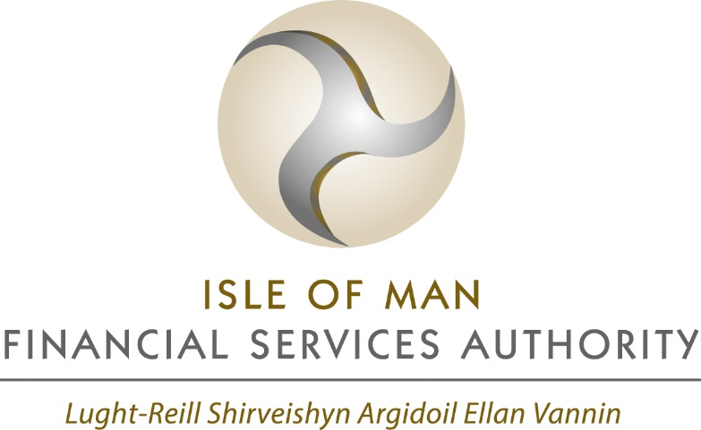

INFORMATION GATEWAYS

SUMMARY OF CONSULTATION RESPONSES
CR17-03/T07

In respect of consultation CP17-06/T07
Closed on 25 July 2017

Glossary of Terms

Term | Meaning in this document
Authority | Isle of Man Financial Services Authority
DBROA15 | Designated Businesses (Registration and Oversight) Act 2015
FIU | Financial Intelligence Unit
FSA08 | Financial Services Act 2008
IA08 | Insurance Act 2008
OFT | Office of Fair Trading
RBSA00 | Retirement Benefits Schemes Act 2000

consultation responses
The following question and summary of responses relates to the Authority’s consultation on proposals to amend the exceptions from restrictions on disclosure (colloquially known as ‘information gateways’) under the DBROA15, FSA08, IA08 and RBSA00.

The consultation was open from 13 June 2017 to 25 July 2017, and responses were received from six external parties: two insurance businesses, one deposit-taker, one trust and corporate services provider, one Isle of Man law firm, and one Statutory Board.

Question asked
- Do you have any comments on the proposed changes to the exceptions from restrictions on disclosure of information?
If so, please can you tell us the reasons for these views.

Four of the respondents stated that they had no comments or concerns regarding the proposed amendments, or they were expressly in favour of the proposals.
Two respondents provided similar comments in relation to the proposal to introduce information gateways to the Cabinet Office - these responses have been summarised below, together with the Authority’s response in relation to the same.

Summary of Feedback and the Authority’s Response
Topic | Feedback | Authority’s Response
Information Gateways to the Cabinet Office | Two responses were received in relation to the proposed information gateways to the Cabinet Office, and why it may need to receive restricted information. | The Authority already has the ability to provide information which would otherwise be restricted to the Cabinet Office under existing, more general, gateways if to do so “enables or assists the Authority to discharge its functions”.  In addition, the provision of information under any gateway remains at the discretion of the Authority, and information will only be provided if the Authority considers the proposed disclosure to be appropriate and reasonable in the circumstances. Each case is considered on its own merits and in the context at the time.  An appropriate circumstance may, for example, involve the provision of information to the Anti-Money Laundering/Combatting the Financing of Terror policy office within the Cabinet Office in relation to certain Designated Non-Financial Businesses and Professions (DNFBPs) in connection with the assessment of risk posed by certain DNFBP sectors pursuant to international AML/CFT standards.

outcome and next steps
Following the recent closure of the consultation on amendments to the information gateways under the DBROA15, FSA08, IA08 and RBSA00, the Authority intends to proceed with the proposed amendments as set out in the original consultation paper.

implementation
It is intended that the three Orders will be made by the Treasury in September 2017, and they will be laid before Tynwald for approval as soon as practicable thereafter.

Subject to Tynwald approval, the Orders are expected to come into operation on 1 November 2017.

16 August 2017.

https://consult.gov.im/financial-services-authority/exceptions-from-restrictions-on-disclosure/supporting_documents/consultation_paper_information_gatew.pdf

